Empathy Map - Electric Motor Temperature Prediction System
Project Name: Electric Motor Temperature Prediction System
Date: 18 February 2026
Team ID: LTVIP2026TMIDS78786
Target User: Maintenance Engineer / Plant Operator / Industrial Supervisor

Empathy Map
Says | “I need to monitor motor temperature continuously.”  “Unexpected motor failures are affecting production.”  “I want early warning before overheating happens.”
Thinks | “Is the motor operating within safe temperature limits?”  “Will this system accurately predict overheating?”  “Can I trust this prediction for maintenance decisions?”
Does | Monitors motor parameters like voltage, current, speed, and stator temperature.  Checks maintenance logs regularly.  Analyzes reports and performance charts.  Takes preventive action when temperature rises.
Feels | Stressed during unexpected breakdowns.  Concerned about equipment damage and downtime.  Relieved when predictive system prevents failure.  Confident when real-time insights are available.

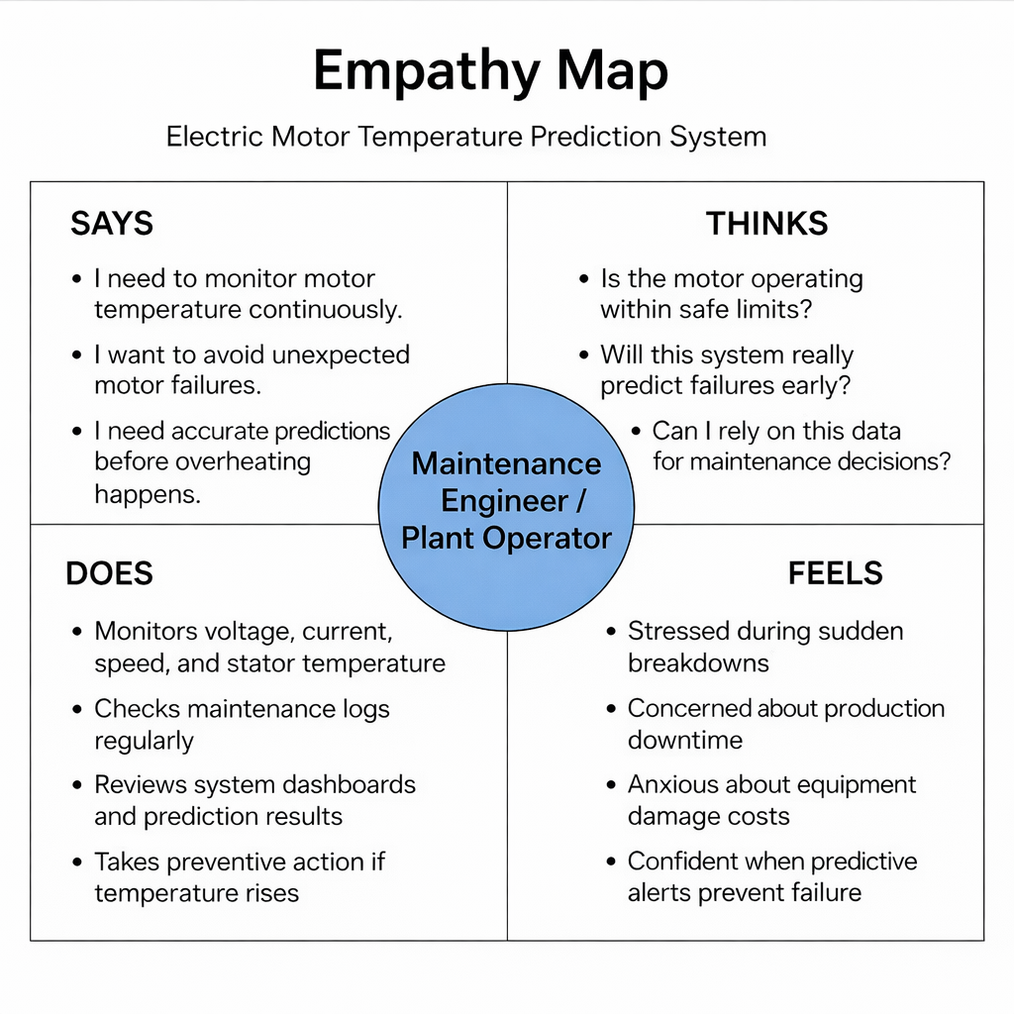

Electric Motor Temperature Prediction System
Project Name: Electric Motor Temperature Prediction System
Date: 18 February 2026
Team ID: LTVIP2026TMIDS78786
🔹 Problem Statement 1
I am a Maintenance Engineer.
I’m trying to monitor electric motor temperature and prevent overheating.
But the current system only provides alerts after temperature crosses a critical threshold.
Because there is no predictive model to forecast temperature rise in advance.
Which makes me feel stressed about unexpected failures, costly repairs, and downtime.
🔹 Problem Statement 2
I am a Plant Supervisor.
I’m trying to ensure smooth production without interruptions.
But I do not have a smart monitoring system that predicts motor health conditions.
Because traditional systems rely only on manual inspection and fixed alarm limits.
Which makes me feel uncertain about equipment reliability and production stability.
🔹 User Perspective Table
Field | Response
I am | A Maintenance Engineer / Plant Operator
I’m trying to | Monitor motor performance and prevent overheating failures.
But | The system only alerts after damage risk increases
Because | There is no machine learning–based predictive analysis
Which makes me feel | Stressed about downtime, repair costs, and production delays

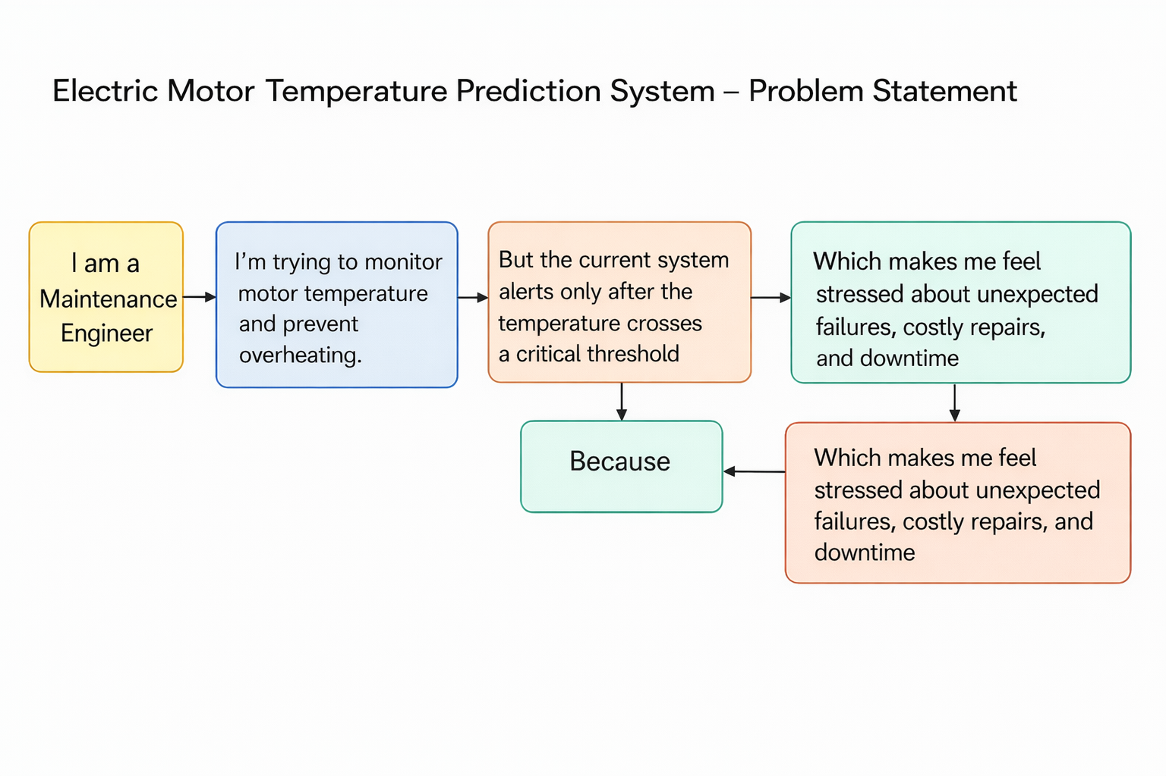

Brainstorming & Idea Prioritization

Project Name: Electric Motor Temperature Prediction System
Date: 18 February 2026
Team ID: LTVIP2026TMIDS78786
Step 1: Problem Statement
Lack of predictive monitoring system for electric motor temperature, leading to unexpected failures, increased maintenance cost, and operational downtime.
Step 2: Idea Listing
• Develop a Machine Learning regression model to predict rotor temperature.
• Perform data preprocessing (null handling, scaling, outlier detection).
• Implement Feature Scaling using MinMaxScaler.
• Train multiple ML models (Linear Regression, Decision Tree, Random Forest, SVR).
• Compare models using RMSE and R² score.
• Select best-performing model (Decision Tree Regressor).
• Save trained model using Pickle.
• Deploy model using Flask framework.
• Create a web interface using HTML & CSS for user input.
• Implement input validation for sensor parameters.
• Display predicted temperature dynamically on webpage.
• Add performance visualization (graphs for model comparison).
• Implement error handling for invalid inputs.
• Future scope: IoT-based real-time sensor integration.
• Future scope: Cloud deployment and alert system.

Step 3: Prioritize Ideas
Ideas | Priority
Data Preprocessing & Feature Scaling | High
Training & Comparing ML Models | High
Model Evaluation (RMSE, R²) | High
Model Deployment using Flask | High
Web Interface for User Input | High
Input Validation & Error Handling | Medium
Performance Visualization | Medium
IoT Integration (Future Scope) | Medium
